Specification for Film Capacitor

1.Part Name
Metalized AC film capacitor with fixed capacitance

2.Dimensions & shape:

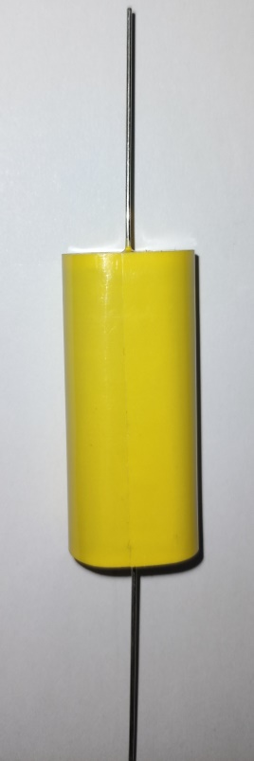

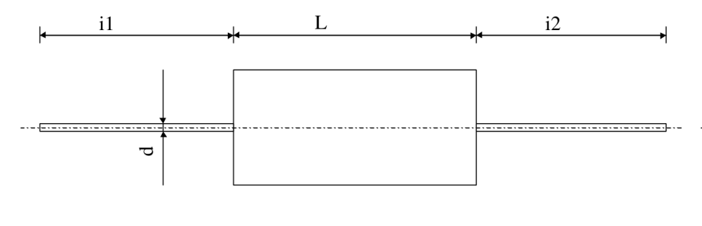

Model No. | L(mm) | d* i1, i2（mm）
CBB20100V1.57μF | L(±2) | d*40(±5)

3.Applications
It has low noise characteristics and are suitable for audio equipments with good sound quality.
It is used for AC circuit, 50Hz.

4.Main characteristics
Ident. No. : Q/RL 234-95
Climate type：55/085/21
Capacitor tolerance: ±5%（J）,±10%(K)

Nominal capacitance (Cn)：1.57μF
Dissipation Factor：≤0.002 （1KHz）
Insulated Resistance：Cr≤0.33uf ≥25000MΩ Cr＞0.33uf ≥7500S
Withstanding Voltage：1.4Un
Small size, light weight, Low dissipation and high reliability

5.Execution
Metalized polypropylene film
Axial lead
Polyester heat-resisting tape,
Epoxy-resin sealing
Vacuum evaporation

Note: We are available to design and produce customized products.

